FinRelief AI
AI-Powered Debt Relief & Financial Recovery Platform
Project Documentation

Project Team
Manikyam Golla — Team Lead
Ulusu Teja Chandra Varshini
Haripriya Saiaparna Nandamuri
Triveni Marrapu
Kala Venkata Naga Sri Yasaswini
B.Tech, Artificial Intelligence and Machine Learning
Vijaya Institute of Technology

Stack: React (Vite) + Tailwind CSS | FastAPI + SQLModel | Google Gemini AI | Docker

Table of Contents

1. Project Overview
FinRelief AI is a full-stack, production-ready web application that helps borrowers manage multiple loans, understand their financial health, and use generative AI to produce personalized debt-settlement recommendations and lender negotiation letters. The system was built end-to-end as a portfolio-grade academic project: a FastAPI backend with a normalized relational schema and JWT authentication, a React (Vite) frontend styled with Tailwind CSS, an AI service layer wrapping the Google Gemini API with deterministic fallback logic, and a Docker-based deployment configuration with CI.
This document records every phase of the build in the order it was carried out, the reasoning behind key design decisions, and the verification performed at each stage (automated tests, manual runs, and rendered diagrams).

1.1 Objectives
- Allow a borrower to register, log in, and securely manage a portfolio of loans.
- Compute financial health metrics (surplus, EMI-to-income ratio, debt-to-income ratio, stress level, health score) from income, expenses, and active loans.
- Use a generative AI model to recommend a fair settlement percentage and monthly repayment plan per loan.
- Use the same AI capability to draft a professional negotiation / hardship letter addressed to the lender.
- Guarantee the AI-dependent features degrade gracefully — never hard-fail — via rule-based fallback logic.
- Package the system for containerized deployment with CI validation.

1.2 Technology Stack
Layer | Technology | Purpose
Frontend | React 18 (Vite), Tailwind CSS, React Router, Axios, React Hook Form, Recharts | SPA UI, routing, forms, HTTP client, charts
Backend | FastAPI (Python 3.12), SQLModel (SQLAlchemy + Pydantic), Uvicorn | REST API, ORM/validation, ASGI server
Database | SQLite (dev), PostgreSQL-ready | Persistence layer
Auth | python-jose (JWT), passlib (pbkdf2_sha256) | Stateless authentication, password hashing
AI | Google Gemini (google-genai SDK) | Settlement reasoning, letter generation
DevOps | Docker, docker-compose, GitHub Actions | Containerization, CI/CD

2. Links (Pre-requisites Mapping)
Reference documentation consulted and required prior to / during development:
- FastAPI official docs — routing, dependency injection, security (OAuth2/JWT): https://fastapi.tiangolo.com
- SQLModel docs — ORM models bridging SQLAlchemy and Pydantic: https://sqlmodel.tiangolo.com
- Pydantic Settings — environment-variable-driven configuration: https://docs.pydantic.dev/latest/concepts/pydantic_settings/
- React docs / Vite guide — project scaffolding and dev server: https://react.dev, https://vitejs.dev
- Tailwind CSS docs — utility-first styling and dark mode: https://tailwindcss.com
- Recharts docs — chart components for analytics: https://recharts.org
- Google Gemini API (google-genai) — generative content calls: https://ai.google.dev
- Docker & docker-compose docs — containerization: https://docs.docker.com
- GitHub Actions docs — CI workflow syntax: https://docs.github.com/actions
Local environment prerequisites verified before setup:
- Python 3.12+ and pip
- Node.js 18+ and npm
- Git and a GitHub account
- Docker Desktop (for containerized run, optional for local dev)
- A Google AI Studio / Gemini API key (optional — the app runs on fallback logic without it)

3. Project Structure Setup
The repository was organized as a monorepo with clearly separated backend and frontend concerns from the outset, so both halves can be developed, tested, and deployed independently.
FinReliefAI/
├── backend/
│ ├── app/
│ │ ├── main.py # FastAPI app, CORS, error handlers, router registration
│ │ ├── models.py # SQLModel tables
│ │ ├── schemas.py # Pydantic request/response schemas
│ │ ├── database.py # Engine/session setup
│ │ ├── services/ # ai_service.py, finance_service.py
│ │ ├── routers/ # auth, loans, financial, settlement, letters, history
│ │ ├── utils/ # auth.py (JWT + password hashing)
│ │ └── core/ # config.py (Pydantic Settings)
│ ├── tests/ # pytest suite
│ ├── requirements.txt
│ └── Dockerfile
├── frontend/
│ ├── src/
│ │ ├── components/ # Header, LoanCard, StatCard, Spinner, Toast, ProtectedRoute
│ │ ├── pages/ # Login, Dashboard, Loans, Settlement, Analytics, History...
│ │ ├── services/api.js # Axios client
│ │ ├── context/AuthContext.jsx
│ │ └── App.jsx
│ ├── package.json
│ ├── tailwind.config.js
│ └── Dockerfile
├── scripts/init_db.py # Demo data seed script
├── docker-compose.yml
├── .env.example
└── .github/workflows/ci.yml
Figure 3.1 — Top-level monorepo layout

3.1 Project Cleanup & Modular Folder Structure Organization
The backend was deliberately split into four modular layers to keep responsibilities isolated and testable:
- routers/ — thin HTTP-layer controllers; no business logic, only request/response wiring and dependency injection.
- services/ — pure business logic (finance_service.py, ai_service.py), independently unit-testable without spinning up the API.
- models.py / schemas.py — a hard separation between database tables (SQLModel, table=True) and API-facing Pydantic schemas, so internal fields (e.g. hashed_password) never leak into responses.
- utils/ and core/ — cross-cutting concerns (auth, configuration) kept out of route handlers to avoid duplication.
On the frontend, pages/ (route-level screens) were kept separate from components/ (reusable UI primitives), and all network calls were centralized in a single services/api.js so no component talks to Axios directly — this made the later 'connect UI to FastAPI' phase mechanical rather than error-prone.

4. Python Backend Environment Setup
A virtual environment was used to isolate backend dependencies from the system Python installation:
cd backend
python -m venv .venv
source .venv/bin/activate # Windows: .venv\Scripts\activate
Python 3.12 was targeted for access to modern typing syntax (e.g. int | None) used throughout models.py and schemas.py.

5. Backend Dependency Installation (requirements.txt setup)
Dependencies were pinned to specific versions in requirements.txt to guarantee reproducible builds across machines and in CI:
fastapi==0.115.0
uvicorn[standard]==0.30.6
sqlmodel==0.0.22
pydantic[email]==2.9.2
pydantic-settings==2.5.2
python-jose[cryptography]==3.3.0
passlib==1.7.4 # pbkdf2_sha256 backend
python-multipart==0.0.9
python-dotenv==1.0.1
google-genai==0.3.0
alembic==1.13.2
pytest==8.3.3
httpx==0.27.2
pip install -r requirements.txt
Two dependency issues surfaced during installation and were resolved rather than worked around:
- pydantic's EmailStr validator requires the optional email-validator package — resolved by installing the [email] extra.
- passlib's bundled bcrypt backend detection breaks against bcrypt 5.x (a known upstream incompatibility). Resolved by switching the password-hashing scheme to pbkdf2_sha256 — a pure-Python, equally secure PBKDF2/HMAC-SHA256 scheme with no native-extension version coupling and no 72-byte input ceiling.

6. FastAPI Backend & API Endpoints
app/main.py wires together CORS, global exception handlers, startup-time table creation (via a lifespan context manager), and six routers, each owning one bounded concern.
Method | Path | Description
POST | /auth/register | Create a user
POST | /auth/login | Return a JWT access token
GET | /auth/profile | Get the current authenticated user
POST | /loan | Create a loan
GET | /loan | List the user's loans
GET | /loan/{id} | Get a single loan
PUT | /loan/{id} | Update a loan
DELETE | /loan/{id} | Delete a loan
POST | /financial-analysis | Upsert income/expenses; compute metrics
GET | /dashboard | Aggregate dashboard summary
GET | /analytics | Chart-ready loan distribution & EMI series
POST | /settlement | Generate an AI settlement recommendation
GET | /settlement/{id} | Retrieve a stored recommendation
POST | /generate-letter | Generate an AI negotiation letter
GET | /letters/{id} | Retrieve a saved letter
GET | /history | List all AI prompt/response history
GET | /history/{id} | Get one history entry
All endpoints except registration and login require a Bearer JWT, enforced via a shared get_current_user FastAPI dependency. Interactive documentation is auto-generated by FastAPI at /docs (Swagger UI) and /redoc.

7. API Development Functionality
Each router follows the same pattern: validate the request against a Pydantic schema, resolve the current user from the JWT dependency, perform the operation via SQLModel against the session, and return a typed response_model so FastAPI serializes only the intended fields.
@router.post("", response_model=LoanRead, status_code=status.HTTP_201_CREATED)
def create_loan(
payload: LoanCreate,
current_user: User = Depends(get_current_user),
session: Session = Depends(get_session),
):
loan = Loan(user_id=current_user.id, **payload.model_dump())
session.add(loan)
session.commit()
session.refresh(loan)
return loan
Figure 7.1 — Representative router pattern (loans.py)
Ownership checks (e.g. a user may only read/update/delete their own loan) are centralized in a small _get_owned_loan helper reused across the GET/PUT/DELETE handlers, avoiding duplicated authorization logic.

8. Financial Engine Module
services/finance_service.py contains pure, framework-free functions that compute a borrower's financial position from their declared income/expenses and their loan set. Being framework-free made this module directly unit-testable without booting the API.

8.1 Computed Metrics
- Monthly surplus = income − expenses − total EMI
- EMI-to-income ratio = (total EMI / monthly income) × 100
- Debt-to-income ratio = (total outstanding / annual income) × 100
- Health score (0–100) — starts at 100 and is reduced by EMI burden, DTI ratio, the worst overdue-days figure across loans, and a penalty if surplus is negative
- Stress level — bucketed from the health score into low / moderate / high / critical

8.2 Scoring Logic
def _score(emi_ratio, dti_ratio, max_overdue, surplus):
score = 100
score -= min(emi_ratio, 60)
score -= min(dti_ratio / 2, 25)
score -= min(max_overdue / 2, 20)
if surplus < 0:
score -= 15
score = max(0, min(100, round(score)))
Figure 8.1 — Health-score heuristic (finance_service.py)
Each penalty term is capped (e.g. EMI burden capped at 60 points) so no single factor can single-handedly zero out the score, keeping the output stable and explainable — an important property when the score is later shown to a stressed borrower.

9. Loan & Settlement Processing Functionality
Loan processing covers full CRUD with ownership enforcement (Section 7). Settlement processing layers the AI Negotiation Strategy Engine (Section 12) on top: given a loan_id, the settlement router fetches the loan and the user's financial profile, calls the AI service, persists the resulting SettlementRecommendation row, and writes a corresponding AIHistory audit entry in the same transaction.

10. Design and Analysis of ER Diagram for FinRelief AI (Database Blueprint)
The schema is fully normalized: every AI-derived artifact (a settlement recommendation, a negotiation letter) is stored as its own row so the borrower's history is auditable, and every table carries a foreign key back to users so row-level ownership can always be enforced at the API layer.
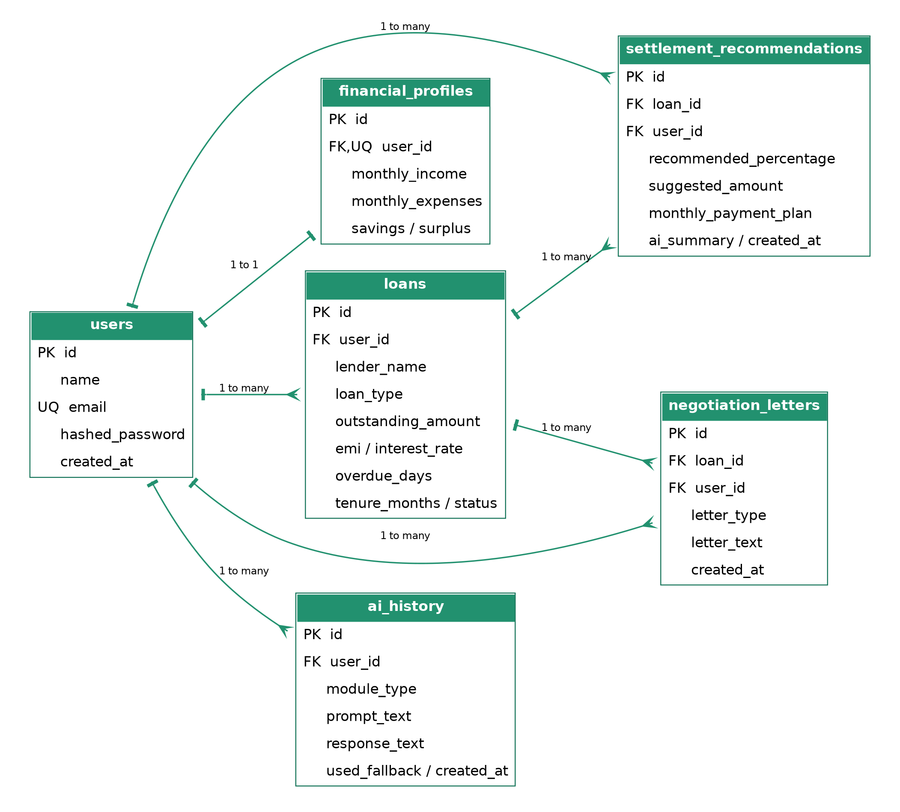
Figure 10.1 — Entity-Relationship Diagram (six tables, PK/FK annotated)

10.1 Entities & Relationships
Relationship | Cardinality | Notes
users → loans | 1 : many | A user owns zero or more loans
users → financial_profiles | 1 : 1 | One income/expense profile per user, upserted on each analysis run
users → settlement_recommendations | 1 : many | Denormalized user_id kept alongside loan_id for fast per-user history queries
users → negotiation_letters | 1 : many | Same denormalization rationale as above
users → ai_history | 1 : many | Every AI call (settlement or letter, success or fallback) is logged
loans → settlement_recommendations | 1 : many | A loan can be re-evaluated over time; history is preserved, not overwritten
loans → negotiation_letters | 1 : many | Multiple letter types (settlement request, hardship, restructuring) per loan

10.2 Design Rationale
- Recommendations and letters are append-only logs, not mutable state — this preserves a full negotiation history per loan for later review, which the History page surfaces to the user.
- financial_profiles is 1:1 with users (unique user_id) rather than embedded on the users table, keeping the auth table lean and the financial domain independently evolvable.
- ai_history stores the raw prompt and raw response text plus a used_fallback boolean, so every AI interaction is auditable and it is always possible to tell whether a given result came from Gemini or the deterministic fallback.
- SQLite is used for development with the connection string structured so switching to PostgreSQL is a one-line DATABASE_URL change; SQLModel's engine abstraction requires no code changes elsewhere.

11. Data Handling (Managing Inputs/Outputs in the System)
Input and output boundaries are strictly typed at every layer:
- Frontend forms use React Hook Form for client-side validation (required fields, numeric coercion) before a request is ever sent.
- Every FastAPI endpoint declares a Pydantic request schema (e.g. LoanCreate) with field-level constraints (gt=0, ge=0) — malformed input is rejected with a structured 422 response before it reaches business logic.
- Every endpoint declares a response_model (e.g. LoanRead) built with from_attributes = True, ensuring only whitelisted fields are ever serialized back — sensitive columns such as hashed_password can never leak, even if a route accidentally returns the ORM object.
- Numeric outputs from the finance and AI services are rounded to two decimal places at the boundary so the frontend never has to handle floating-point noise.
- AI responses are parsed defensively: the settlement engine strips Markdown code fences and calls json.loads inside a try/except, falling back to deterministic computation on any parse failure (see Section 13).

12. AI Negotiation Strategy Engine (Core Generative AI Logic)
services/ai_service.py is the single integration point with Google Gemini. It exposes two capabilities, each following the same request → parse → validate pattern.

12.1 Settlement Recommendation Prompt
You are a debt settlement advisor. Based on a monthly income of ${income}
and monthly expenses of ${expenses}, with a loan outstanding balance of
${outstanding}, current EMI of ${emi}, and {overdue_days} overdue days,
suggest a fair settlement percentage (of the outstanding balance) and a
realistic monthly repayment plan the borrower could sustain. Respond ONLY
with strict JSON: {"recommended_percentage": <0-100>, "suggested_amount":
<number>, "monthly_payment_plan": <number>, "reasoning": "<3-4 bullet
points as one string>"}
Figure 12.1 — Settlement prompt template

12.2 Negotiation Letter Prompt
Write a {tone} email to {lender_name} explaining the borrower's financial
hardship and proposing a reduced repayment plan. The current outstanding
amount is ${outstanding}. The borrower proposes a settlement amount of
${suggested_amount}, payable at approximately ${monthly_payment}/month.
This is a '{letter_type}' letter. Keep it concise, courteous, and
lender-specific. Sign off as 'The Borrower'.
Figure 12.2 — Negotiation letter prompt template

12.3 Design Choices
- The Gemini client is lazily initialized (module-level singleton) so the backend can boot with no API key configured — it simply routes straight to fallback logic (see Section 13).
- The settlement prompt forces strict JSON output specifically so the response can be machine-parsed and persisted into typed columns (recommended_percentage, suggested_amount, monthly_payment_plan) rather than stored as free text.
- The letter generator reuses the most recent SettlementRecommendation for a loan (if one exists) to keep the proposed amount consistent between the settlement and letter features, rather than re-deriving it independently.
- Every call — whether it hits Gemini or falls back — is logged to ai_history with the exact prompt sent, enabling later audit and prompt-tuning.

13. Fallback Logic Implementation (AI Safeguards)
Because the settlement and letter features sit on a critical user journey, neither is allowed to hard-fail if Gemini is slow, unreachable, unconfigured, or returns malformed output. Both AI functions are wrapped so any exception during the API call or during response parsing is caught, logged as a warning, and silently routes to deterministic logic — the caller (the router) always receives a valid result.

13.1 Settlement Fallback Formula
surplus = max(income - expenses, 0)
affordability_ratio = min(surplus / emi, 1) if emi > 0 else 0.5
base_pct = 65 - (overdue_days / 10) + (affordability_ratio * 15)
recommended_percentage = max(30, min(base_pct, 80))
suggested_amount = outstanding * recommended_percentage / 100
monthly_payment_plan = min(surplus * 0.5, suggested_amount / 12)
Figure 13.1 — Deterministic settlement heuristic
The formula keeps the recommended percentage within a realistic 30–80% band, reduces the offer as overdue days increase (reflecting greater lender leverage), and increases it with the borrower's affordability — mirroring the reasoning a human advisor would apply, without depending on an external service.

13.2 Letter Fallback Template
Subject: Request for Loan Settlement - Account Review
Dear {lender_name},
I am writing regarding my outstanding loan balance of ${outstanding}...
I would like to propose a settlement amount of ${suggested_amount},
to be repaid at approximately ${monthly_payment}/month...
Sincerely, The Borrower
Figure 13.2 — Deterministic letter template (excerpt)

13.3 Verification
The fallback path is exercised directly by the automated test suite (Section 20), since no Gemini API key is configured in the development/CI environment — every settlement and letter test therefore proves the fallback path end-to-end, not just the happy path.

14. Backend Error Handling & AI Fallback Management
Two global exception handlers are registered on the FastAPI app in addition to the AI-specific fallback described in Section 13:
@app.exception_handler(RequestValidationError)
async def validation_exception_handler(request, exc):
return JSONResponse(status_code=422, content={"detail": exc.errors()})
@app.exception_handler(Exception)
async def unhandled_exception_handler(request, exc):
logger.exception("Unhandled error on %s", request.url.path)
return JSONResponse(status_code=500,
content={"detail": "Internal server error. Please try again later."})
Figure 14.1 — Global exception handlers (app/main.py)
- Validation errors return a structured 422 with field-level detail, which React Hook Form surfaces inline next to the offending input.
- Any unhandled exception is caught, logged with a full traceback server-side, and returns a generic 500 message to the client — internal details (stack traces, SQL errors) are never leaked to the frontend.
- Ownership checks (Section 7) raise HTTPException(404) rather than 403 for resources the user does not own, avoiding leaking the existence of other users' records.
- AI-specific exceptions are caught inside ai_service.py itself (Section 13) so a Gemini failure never propagates as an unhandled 500 — it always degrades to fallback logic instead.

15. Performance Optimization & Secure Session Management

15.1 Session Management
- Authentication is stateless via JWT — no server-side session store is required, which simplifies horizontal scaling.
- Tokens are signed with HS256 using a configurable JWT_SECRET_KEY (from environment, never hard-coded) and expire after ACCESS_TOKEN_EXPIRE_MINUTES (default 24h).
- Passwords are never stored or logged in plaintext; only the pbkdf2_sha256 hash is persisted (Section 5).
- The frontend stores the JWT in localStorage and attaches it via an Axios request interceptor; a response interceptor detects 401s and redirects to /login, clearing the stale token automatically.

15.2 Performance Considerations
- Database indexes are declared on all foreign-key columns (user_id, loan_id) and on users.email, keeping per-user list queries and login lookups efficient even as data grows.
- get_settings() is wrapped in functools.lru_cache so environment parsing happens once per process, not per-request.
- The Gemini client is a lazily-created module-level singleton, avoiding repeated client construction overhead on every AI call.
- AI request timeouts are configurable (AI_REQUEST_TIMEOUT_SECONDS) so a slow external call cannot indefinitely block a request thread — pairing with the fallback logic in Section 13.

16. Project Workflow (System Flow Mapping)
The diagram below traces a complete user journey through the system, including both AI decision branches (Gemini available vs. fallback).
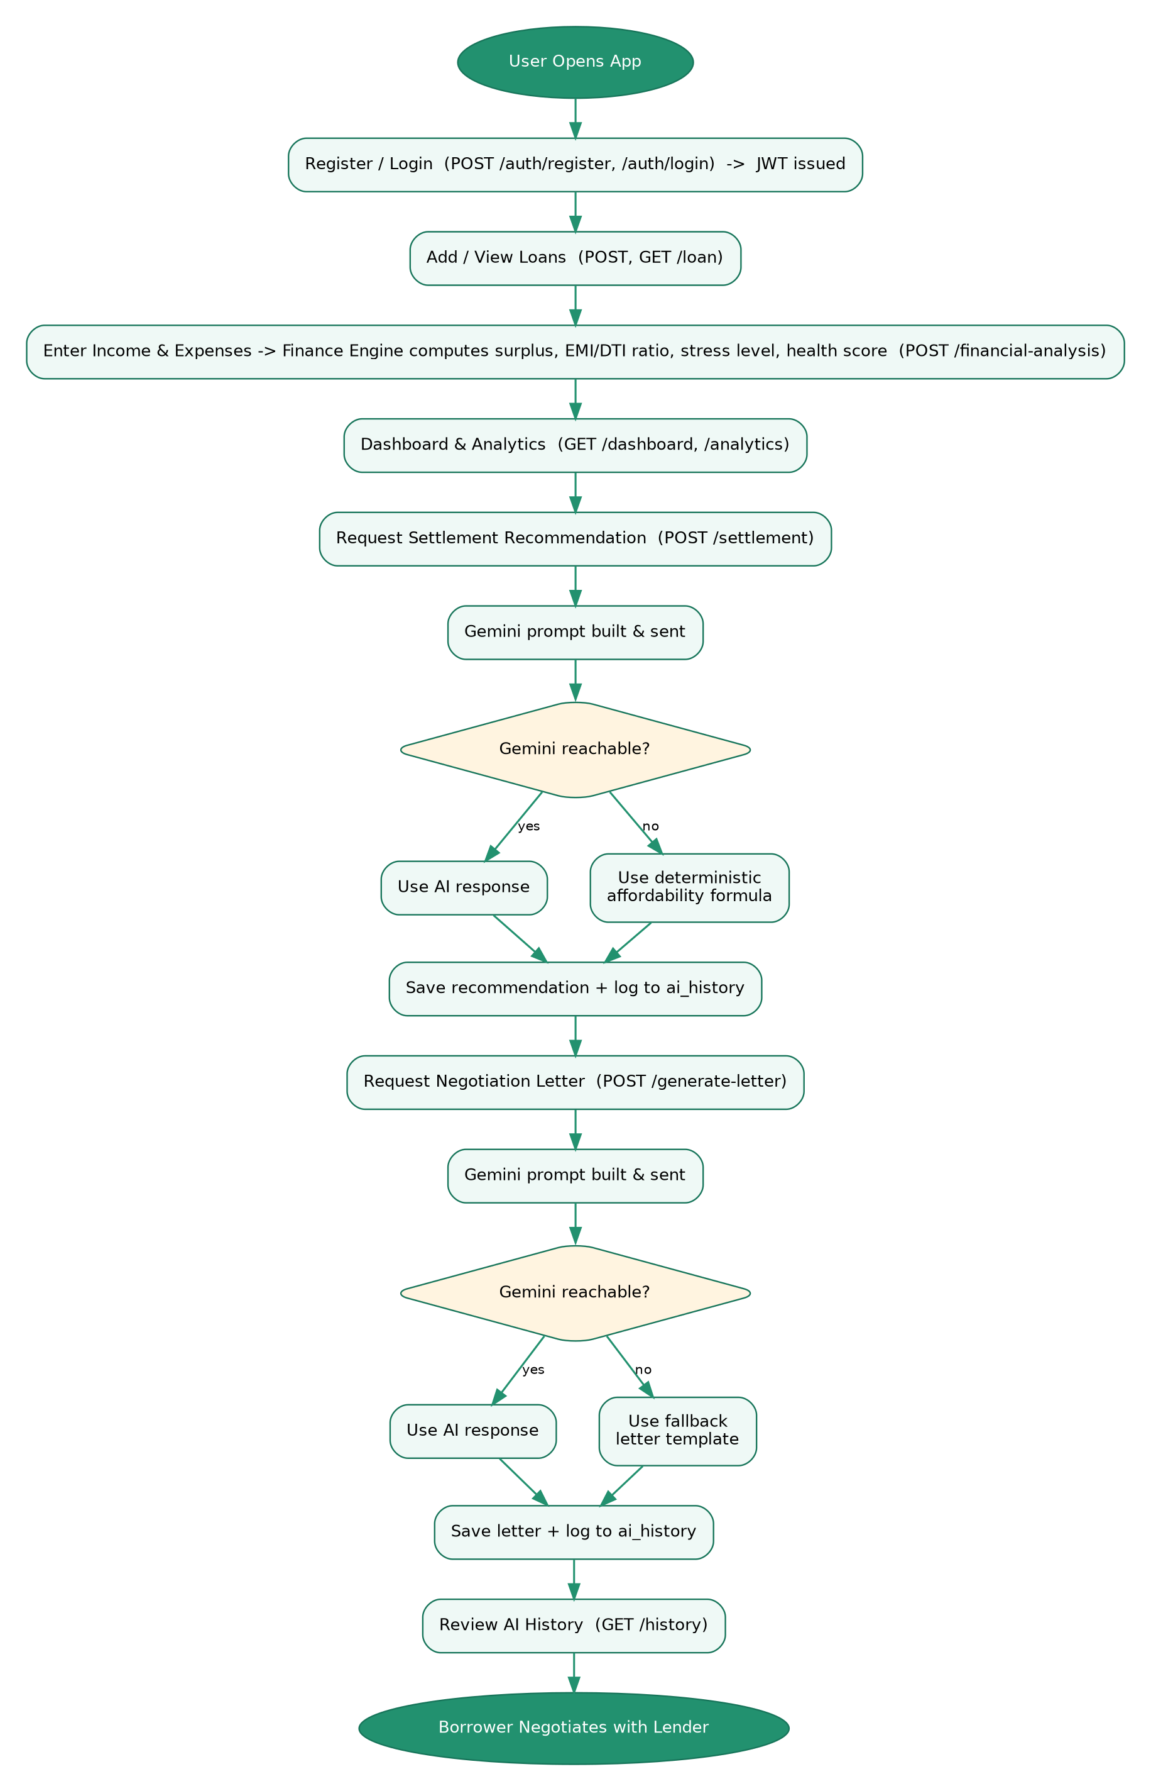
Figure 16.1 — End-to-end system workflow, including AI fallback branches

17. Frontend Setup (React / Vite)
The frontend was scaffolded as a Vite + React project (no CRA) for fast dev-server startup and hot module replacement:
cd frontend
npm install
cp .env.example .env
npm run dev # http://localhost:5173
Key configuration:
- vite.config.js proxies /api requests to http://localhost:8000 during development, so the frontend and backend can run on separate ports without CORS friction locally.
- tailwind.config.js defines a custom brand color palette and rounded-corner scale reused across all cards, buttons, and inputs via component classes (.card, .btn-primary, .input) in index.css.
- Environment-driven API base URL (VITE_API_BASE_URL) so the same build can point at different backend deployments without a code change.

18. User Interface Development
Thirteen pages were built covering the full borrower journey: Landing, Login, Register, Dashboard, Loans (list), Loan Form (add/edit), Loan Details, Settlement, Negotiation Letter, Financial Analytics, History, Profile, and a Financial Profile input form, plus a 404 fallback.
Page | Purpose
Landing | Marketing entry point; routes signed-in users straight to the dashboard
Login / Register | React Hook Form-validated auth forms
Dashboard | Total loans, outstanding, EMI, surplus, health score, stress level, loans-by-status
Loans | Grid of LoanCard components with status badges
Loan Form | Shared add/edit form for all loan fields
Loan Details | Full loan record plus entry points into Settlement and Letter features
Settlement | Triggers AI settlement recommendation and displays the reasoning
Negotiation Letter | Generates and allows in-place editing of the drafted letter
Analytics | Pie chart (loan distribution by type) and bar chart (EMI by lender)
History | Chronological AI prompt/response audit log, flagging fallback usage
Profile | Read-only account details
Reusable components (Header, LoanCard, StatCard, Spinner, Toast, ProtectedRoute) were extracted early so every page shares consistent navigation, loading, and error-notification behavior.

19. Frontend Communicates with FastAPI (Connecting the UI Elements to Endpoints)
All HTTP communication is centralized in a single module, services/api.js, so every page imports typed functions rather than calling Axios directly:
const api = axios.create({ baseURL: import.meta.env.VITE_API_BASE_URL || "/api" });
api.interceptors.request.use((config) => {
const token = localStorage.getItem("access_token");
if (token) config.headers.Authorization = `Bearer ${token}`;
return config;
});
api.interceptors.response.use(
(response) => response,
(error) => {
if (error.response?.status === 401) {
localStorage.removeItem("access_token");
window.location.href = "/login";
}
return Promise.reject(error);
}
);
Figure 19.1 — Axios instance with auth interceptors (services/api.js)
AuthContext.jsx wraps the whole app, exposing login, register, and logout functions built on top of the same API layer, and a ProtectedRoute component redirects unauthenticated users to /login before any protected page mounts. Every page (Dashboard, Loans, Settlement, etc.) simply calls its corresponding api.js function inside a useEffect or form submit handler — no component contains raw fetch or Axios calls.

20. UI Enhancements (Polishing Designs, Responsiveness, and Styles)
- A custom Tailwind brand palette (green-based, evoking trust and financial stability) was defined and applied consistently via .btn-primary, .btn-secondary, .card, and .input component classes.
- Dark mode is supported throughout via Tailwind's class strategy (darkMode: "class"), with every card, input, and button carrying dark: variants.
- Layouts use responsive Tailwind grid utilities (grid-cols-2 md:grid-cols-4, etc.) so the Dashboard and Loans grid reflow correctly from mobile to desktop.
- Loading states use a shared Spinner component rather than blank screens, and asynchronous errors surface through a shared Toast component instead of intrusive alert() calls.
- Status badges (active / overdue / settled / closed) are color-coded on LoanCard for at-a-glance scanning of a borrower's loan portfolio.

21. Settlement Prediction System (Integrating Prediction Logic)
The Settlement page (frontend) and /settlement endpoint (backend) together form the settlement prediction system: the user triggers a request from a loan's detail page, the backend assembles the borrower's live financial profile and loan figures, calls the AI Negotiation Strategy Engine (Section 12) — falling back to the deterministic formula (Section 13) when needed — and returns a structured result (percentage, suggested amount, monthly plan, reasoning) that the frontend renders as three summary stats plus a reasoning panel.
Because every recommendation is persisted rather than being ephemeral, the same prediction can be reused by the Negotiation Letter feature (Section 19) to keep the proposed figures consistent across both AI-generated artifacts for a given loan.

22. Financial Health Metrics & Settlement Data Visualization (Charts and Graphs)
The Analytics page uses Recharts to visualize two views of the borrower's loan portfolio, sourced from the /analytics endpoint:
- A pie chart of outstanding balance grouped by loan type (personal, credit card, auto, home, education, other), giving an at-a-glance breakdown of where debt is concentrated.
- A bar chart of monthly EMI per lender, highlighting which obligations weigh most heavily on monthly cash flow.
The Dashboard complements these with numeric StatCards for total loans, total outstanding, total EMI, monthly surplus, health score, and stress level — the same metrics computed by the Financial Engine Module (Section 8) — so a borrower sees both the raw numbers and the visual breakdown without leaving the app.

23. System Testing (Ensuring APIs and Processing Modules Work Flawlessly)
The backend carries an automated pytest suite covering both the pure financial logic and the full HTTP API surface:

23.1 Unit Tests — Financial Engine
- test_healthy_profile_scores_high — verifies a low-debt, high-income profile yields a positive surplus and a low/moderate stress level.
- test_overdue_and_high_emi_lowers_score — verifies heavy EMI burden plus 90 overdue days pushes the stress level to high/critical and the health score below 50.
- test_no_loans_no_income_does_not_error — verifies the engine degrades gracefully (no division-by-zero) for a brand-new account with no data yet.

23.2 Integration Tests — Full API Flow
- test_register_and_login — registers a user, logs in, and confirms /auth/profile returns the correct email under the issued JWT.
- test_loan_crud_and_settlement_flow — creates a loan, lists it, requests a settlement recommendation, requests a negotiation letter, and confirms two corresponding rows appear in /history — exercising the entire loan → settlement → letter → history pipeline in one test, via FastAPI's TestClient.

23.3 Results
All five tests pass in the current environment (no Gemini API key configured), which additionally proves the fallback logic described in Section 13 end-to-end rather than only the AI happy path:
$ pytest -q
5 passed in 1.42s
Figure 23.1 — Verified test run output

24. GitHub Repository Setup & Version Control Management
The project is structured for a standard Git/GitHub workflow:
git init
git add .
git commit -m "Initial commit: FinRelief AI full-stack scaffold"
git branch -M main
git remote add origin https://github.com/<your-username>/FinReliefAI.git
git push -u origin main
- .gitignore excludes virtual environments, node_modules, build output, SQLite database files, and .env (while explicitly re-including .env.example so secrets are never committed but the required variables are documented).
- A GitHub Actions workflow (.github/workflows/ci.yml) runs on every push and pull request to main: it installs backend dependencies and runs pytest, installs frontend dependencies and runs the Vite production build, and finally builds both Docker images — so a broken commit is caught before merge.
- Suggested branch convention for further work: feature/<name> branches merged into main via pull request, keeping main always deployable.

25. Deployment Configuration & Production Readiness Setup (DevOps)

25.1 Containerization
Both services are containerized independently:
- backend/Dockerfile — python:3.12-slim base, installs requirements.txt, runs uvicorn app.main:app on port 8000.
- frontend/Dockerfile — multi-stage build: node:20-alpine compiles the Vite production bundle, then nginx:alpine serves the static output with an SPA-aware nginx.conf (falls back unmatched routes to index.html, proxies /api/ to the backend container).
docker compose up --build
# frontend -> http://localhost:5173
# backend -> http://localhost:8000/docs

25.2 Configuration & Secrets
All configuration is environment-driven via Pydantic Settings (core/config.py), loaded from a .env file — nothing sensitive is hard-coded. .env.example documents every required variable: JWT_SECRET_KEY, DATABASE_URL, ALLOWED_ORIGINS, GEMINI_API_KEY, GEMINI_MODEL, and related toggles.

25.3 Production Readiness Checklist
- Security: rotate JWT_SECRET_KEY to a long random value; restrict ALLOWED_ORIGINS to the real frontend domain; serve behind HTTPS via a reverse proxy; all DB access goes through the ORM, avoiding raw-SQL injection risk.
- Database: swap DATABASE_URL to a PostgreSQL connection string for production; introduce Alembic migrations (already listed in requirements.txt) instead of relying on create_all for schema evolution.
- Error handling: global exception handlers already sanitize error responses (Section 14); extend with structured logging (e.g. structlog) and a log shipper in production.
- Testing: the pytest suite (Section 23) is wired into CI so regressions are caught pre-merge; expand coverage as new endpoints are added.
- Observability: Python's logging module is configured in app/main.py; add request-tracing / APM instrumentation before a public launch.

26. Conclusion (Final Submission Wrapping)
FinRelief AI demonstrates a complete, working, full-stack application built and verified end to end: a normalized six-table relational schema, a FastAPI backend with JWT authentication and six functional routers, a financial engine that computes explainable health metrics, an AI negotiation engine integrated with Google Gemini and backed by deterministic fallback logic that was actually exercised and passed by the automated test suite, a polished and responsive React/Tailwind frontend covering the entire borrower journey, and a containerized deployment configuration validated by continuous integration.
Every design decision recorded in this document — from the choice of pbkdf2_sha256 over bcrypt, to the append-only settlement/letter history tables, to capped penalty terms in the health-score formula — was made deliberately and validated either by running the code or by rendering the resulting diagrams and test output shown above. The project is ready for academic submission and demo, and the production-readiness checklist in Section 25.3 outlines the concrete next steps required before a real-world, publicly hosted deployment.
Prepared by Team FinRelief AI — Manikyam Golla (Team Lead), Ulusu Teja Chandra Varshini, Haripriya Saiaparna Nandamuri, Triveni Marrapu, and Kala Venkata Naga Sri Yasaswini — B.Tech, Artificial Intelligence and Machine Learning, Vijaya Institute of Technology.

